How to Prepare Your MoodleMoot Proceedings Report in MS-Word
(Version 5.0)
TAKAYUKI MATSUKI^{†1}
This manuscript is a guide to produce a final camera-ready manuscript of a PDF to be submitted to MoodleMoot Proceedings using MS-Word template file. Since the manuscript itself is produced with the MS-Word template file, it will help reduce time required for formatting and production of the final proceedings draft. This paragraph is for a bilingual abstract of 400 characters in Japanese and 200 words in English. For English papers, the Japanese language abstract MUST be polished and mistake free. This is the FIRST part that will be reviewed and the paper may be instantly rejected if the quality of the abstract is poor. In this case, resubmission will also be prohibited. Your final .pdf will be printed “as is” so be sure to have a colleague proofread your earlier drafts. This includes poster presentations, workshops, lightning talks and keynote addresses.
MS-WordによるMoodleMoot Proceedings原稿作成ガイド
（第5.0版）
松木孝幸^{†1}
このパンフレットは、MoodleMootのProceedingsの原稿を、MS-Wordを用いて作成し提出するためのガイドである。このパンフレットでは、原稿作成のためのMS-Wordテンプレートファイルについて解説している。また、このパンフレット自体も会議録原稿と同じ方法で作成されているので、必要に応じて雛形として参照されたい。英語で書かれた記事の場合、日本語抄録と題名も書く必要がある。査読の第一段階として日本語抄録と題名を確認する。もし、英語の誤りが散見された場合は即却下とされ、再投稿の機会も失われる。提出された原稿はそのままPDFファイルにされるので、厳密な原稿の校正をお願いします。

Introduction
The Moodle Association of Japan (MAJ) is publishing Proceedings of MoodleMoot Japan Annual Conference as a report of the conference and as a basis for an international journal in the future. For this report, MAJ has adopted a portrait A4 format.
All authors should copy this file to prepare your report. It should be saved as a camera-ready .docx file and submitting to the Editor. This template ﬁle is based on MS-Word. You may use other word-processing software to prepare your manuscript, but please follow the format of this template precisely. This will greatly assist the editors who are volunteering their time for this project. In the following sections of this manuscript, we describe usage of the template ﬁle.

Configuration of Page Layout

Template of MS-Word is obtained from the following URL. If you cannot access to the internet, please email to editor@moodlejapan.org.

MS-Word template file
http://moodlejapan.org/journal/submit/wordtemp.zip
Template file consists of two sections as seen from Fig. 1.
①Title, Authors, Abstract (write both in English and Japanese)
②Texts, Acknowledgements, References, Appendices

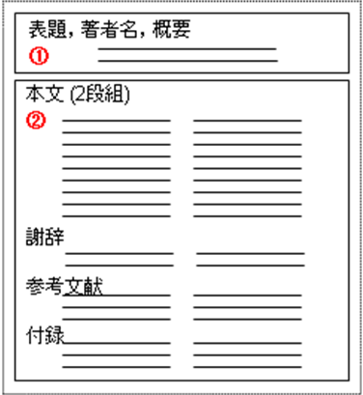
Figure 1 The configuration of template file.

Margins (See Fig. 2)
Top: 22mm, Bottom: 25mm, Left: 17mm, Right: 17mm

Number of characters per line and lines per page (See Fig. 3)
Number of characters per line: 26
Number of lines per page: 56
Number of Columns: 2

Font (See Fig.4)
Style: Normal
Font type: Yu Gothic
Font size: 9 pt

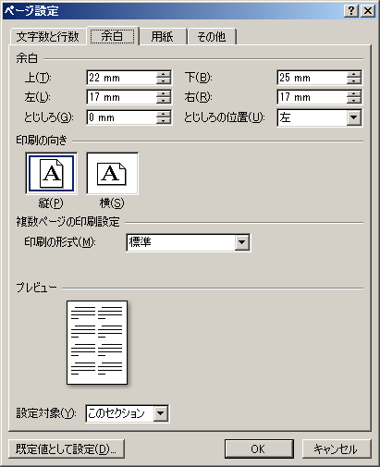
Figure 2 Page Configuration: Space (MS-Word 2007).
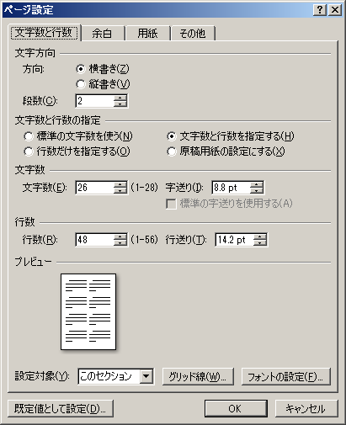
Figure 3 Page Configuration: Character and Line (MS-Word 2007).

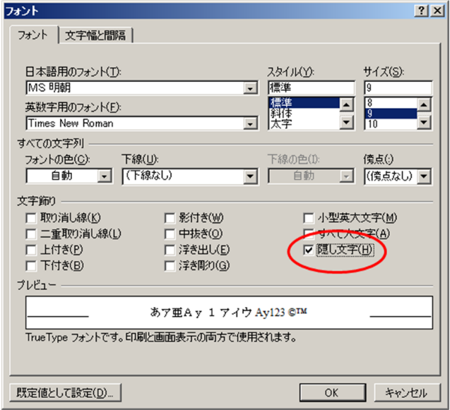
Figure 4 Font Configuration (MS-Word 2007).

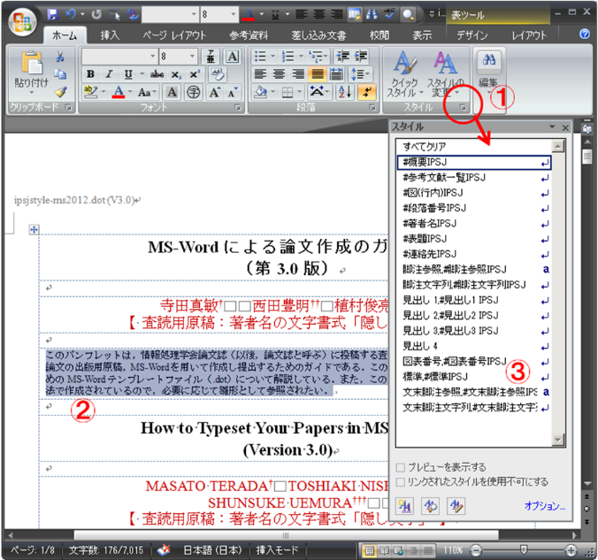
Figure 5 Configuration of style set (MS-Word 2007).
Operations of styles in MS-Word 2007 are explained in the following. Please refer to Ref. [2] in details.
- Click the right-below button of [Home]-[Style] and show a list of items in [Style] (See Fig. 5-①).
- Set a cursor on the paragraph on which you want to set style. (Fig.5-②）．
- Click on the style you want from a list of [Style] box (Fig.5-③).

One has to be careful when applying styles so that style set should not be changed which is provided in Table 1.

Table 1 Set of Style in MS-Word template file.
スタイル名 | Purpose | Font name | Font size | Character  alignment
#表題MAJ | 表題 | Yu Gothic（太字） | 14pt | Centering
#標準MAJ | 本文 | Yu Gothic | 9pt | Align  both edge
#概要MAJ | 概要 | Yu Gothic | 8pt | Alignment  of both edge
#著者名MAJ | 著者名 | Yu Gothic | 12pt | Align left
#見出し1  MAJ | 節の  見出し | Yu Gothic（太字） | 11pt | Align left
#見出し2  MAJ | 小節の  見出し | Yu Gothic（太字） | 9pt | Align left
#段落番号  MAJ | 番号付きの箇条書き | Yu Gothic（太字） | 9pt | Align  both edge
#箇条書き  MAJ | 黒丸の箇条書き | Yu Gothic | 9pt | Align  both edge
#脚注参照  MAJ | 脚注参照用のラベル | Yu Gothic | 9pt | －
#脚注文字列  MAJ | 脚注 | Yu Gothic | 7pt | Align left
#文末脚注  参照MAJ | 文末脚注参照用のラベル | Yu Gothic | 9pt | Align left
#文末脚注  文字列MAJ | 参考文献の記述など | Yu Gothic | 8pt | Align left
#図表番号  MAJ | 図表番号の題目 | Yu Gothic | 9pt | Centering

- In “Change style”, one should not check “Automatic renewal” (Fig. 6).
- In “Change style of character/paragraph”, do not select “Renew sentences which match with selected ones” (Fig. 7).
- In “Change style of character/paragraph”, do not select “”. (Fig. 8).「文字/段落スタイルの変更」に関して，「スタイルに登録されている書式を更新する（エラー! 参照元が見つかりません。）」を選択しないこと．

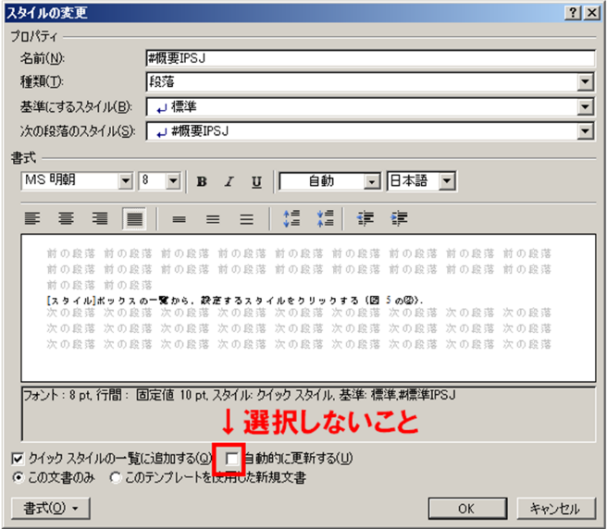
Figure 6 Change of style set (MS-Word 2007).

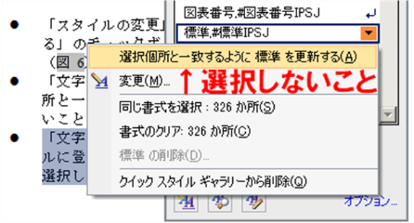
Figure 7 Change of Character/Paragraph Configuration (MS-Word 2007).

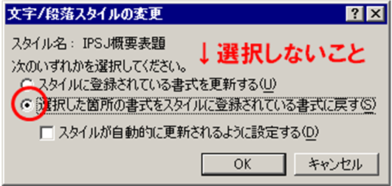
Figure 8 Change of Character/Paragraph Configuration (MS-Word 2003).

Figures and Tables
We encourage authors to include figures, diagrams, screenshots and other visual material in their report. Tables are also very useful for summarizing information and highlighting key points.
With regard to style for numbering of figures, use Word style or refer to styles of Table 1. When describing number of tables, figures and equations, we use MS-Word automatic function for “Numbering for Figure and Table”.

Layout of object = in front

Figure 9 Layout of the figure object.

Operations in MS-Word 2007 are as follows.
- Put a cursor on a paragraph which describes Figure/Table. Click [Reference]-[Insertion of Number for Figure/Table] (Fig. 10-①).
- Select the label (for Figure/Table, etc.) from a list of [Label names] in the box [Number of Figure/Table] and click [OK] (Fig. 10-②③).

If you want use English names for labels (“Figure”, “Fig.”, “Table” etc.), create a new label name after clicking [Label names] (Fig. 10-④), then do the above operation.

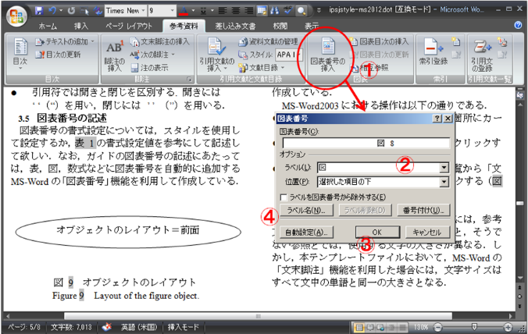

Figure 10 Configuration of chart number.

List of References
Font type: Yu Gothic
Font size: 8 pt (Align left)
In Reference section, refer only references cited in the main text in principle.
List the names of the authors in alphabetical order at the end of the manuscript.

Check List of “Dos and Don’ts”

The basics of way of writing
- Describe a paper so that readers understand the novelty, availability, and reliability of the research.
- Try to make a paper be easy to read (discontinuity of the story, and obscure backgrounds or themes are burden to readers).
- If the paper, is a case study or localized problem, it should describe the case in rich detail. At the end, limited general implications should be suggested.
- Rethink the paper if its conclusion is not clearly described, it does not adequately point out its applicability, limits, and controversial points, or its conclusion does not follow the contents.
- Avoid colloquial style.
- Do not make the paper difficult to grasp the meaning without a guess from the context.
- Confirm your conclusions at the end, but do not overstate.
- The authors should not submit a manuscript including some redundant and/or too brief descriptions. A minimum of 4000 words in English is required for refereed paper. If your article needs to extend beyond 5000 words, please contact the editors.

About references
- Follow the APA version 6 format for references.
Double spacing is used throughout this page.
Alphabetize entries by authors’ last names.
Create a hanging indent for each individual source you add to the list. A hanging indent is where the second and all the following lines of a paragraph are indented more than the first.
- Capitalize the author’s last name whether it appears first (e.g. YAMADA, T.) . Citations within the text should follow the following format: (i.e.) Yamada (2008a) reports… or …was indicated. (Yamada 2008b).
- References to books
Author’s Last-Name, First-Initial. Middle-Initial. (Year of Publication). Title of Book: Subtitle. Location: Publisher.
- References to journals
Author’s Last-Name, First-Initial. Middle-Initial. (Year of Publication). Title of Article. Title of Journal, Volume Number (Issue Number), Pages.
- References to web
Author’s Last-Name, First-Initial. Middle-Initial. (Year, Month & Date of Publication). Title of Article. Retrieved from URL

- The number of references should be roughly 10 (in some cases, more than 20 may be acceptable) in refereed paper. Workshops and plugin demonstrations may have fewer. Please refer to relevant sections of Moodle Docs if you have less than 5 references.
- Do not over-use self-citations.

Miscellaneous
- Fill the self-check sheet carefully before submitting the paper.

Concluding Remarks
We don’t assume that the template ﬁles are perfect, but wish to improve them with your cooperation and hope you let us know your compliment, comments and suggestions by e-mail to editor@moodlejapan.org.

Acknowledgments
This manuscript is based on the LaTeX style ﬁle for A4 landscape type papers of Information Processing Society of Japan (IPSJ). Thanks for the members eﬀort to prepare the previous and LaTeX version of IPSJ.

References
Word: help and how-to, http://office.microsoft.com/en-us/word- help/CH010097020.aspx
Word: help and how-to, http://office.microsoft.com/en-us/word- help/CL010072933.aspx

†1 Tokyo Kasei University

